|  |  |
| --- | --- |
| **Orienteering**  **Geocaching Game** | C:\Users\james\OneDrive\BSA\Woodbadge\Project\EEE Flag Color.JPG |

**Geocaching Description**

Geocaching is a treasure hunting game using navigation skills. There is an online group that has a record of different caches located all over the world. The caches have different difficulty levels on the website, so that you can look for a cache that is on your skill level. Once you have located the cache, open it up and sign the log. There may be small items in the cache, and the rule is if you take an item then you must leave an item of equal value.

**Getting Started**

1. Register for a free basic membership at geocaching.com or by using the link.
2. Visit the “Hide and Seek Cache" page.
3. Enter your postal code and click "search."
4. Choose any geocache from the list and click on its name.
5. Enter the coordinates of the geocache into your GPS Device.
6. Use your GPS device to assist you in finding the hidden geocache.
7. Sign the logbook and return the geocache to its original location.
8. Share your geocaching stories and photos online.

**Smart Phone Apps**

To download iPhone and Android Geocaching apps visit <http://www.geocaching.com/play/mobile>

**Equipment:**

* A phone with GPS locating or a GPS locater
* Membership to geocaching.com (Free)

**Understanding the Lingo**

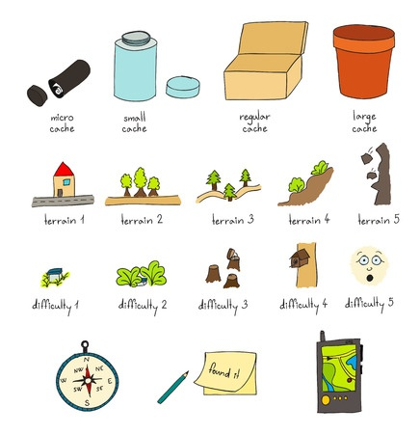

**https://www.geocaching.com/**



**Object:** Use navigating skills to locate a set of GPS coordinates where a cache or container is placed.